**API and Its Types**

* API is an Application Programming Interface that enables interaction, access, and data / functionality exchange between two separate software systems. In essence, an API mediates the connection between the systems via an interface, creating an environment for their interaction. There are several types of API, such as database API, operating system API, but the most common ones are web API.

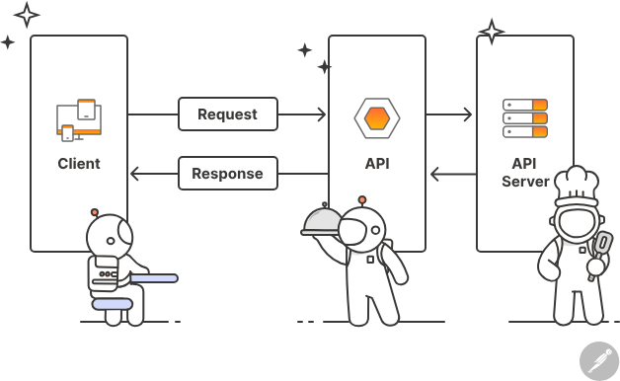

* On a technical front, an API is a set of tools, communication protocols, and subroutine definitions for building software It’s a resource for developers that lets them work without digging into the source code of a program. For example, a developer can use the interface to retrieve the required data or functionality.
* An API consists two entities:
  + Specification. This is basically a contract that describes data exchange terms. As such, an API answers the question of ways how to retrieve the data.
  + An interface that complies with a specification. It can be SOAP, REST interface as well as another API.

**How do they work?**

* A popular analogy is a restaurant. When ordering at a restaurant, you are given a menu with dishes listed. We usually go about this in one way – by saying our order and having a dish prepared.
* In software development, a menu stands for an interface. Everything listed here is what you can obtain by ordering. What’s not on the menu cannot be served by default. An API helps a software system to request and receive specific data types from another software system. A waiter facilitates the food delivery process, acting as a mediator between kitchen staff and a visitor. To tie it back to API, when an application needs to access data from another application, it calls its API, specifying what data it needs to retrieve. The other application provides data requested by the first application.

* Application Programming Interfaces are used for multiple purposes. For one, they let developers create feature-rich products faster. With an API, they can enrich products with additional functionality without having to develop it from the ground up. APIs also facilitate software support. Developers use a trusted API, while adding their own code to connect their software to another one. In this case, they only need to support the code written by them.

**What types of API are there?**

* The developers can choose from a range of protocols and standards when creating a new one, depending on the type of API they want to create and for what purpose.
* The most common are Web APIs, meaning APIs designed for the web. Web APIs are used as a platform for creating HTTP services. These APIs are used to add more functionalities on web apps like Google Maps or authorization via socials.

Web APIs can be divided into the following types according to their specifications:

* RPC (Remote Procedure Call)
* SOAP (Simple Object Access Protocol)
* REST (Representational State Transfer)
* GraphQL

**Remote Procedure Call (RPC)**

* Some Web APIs follow the data exchange principles based on a RPC, a protocol that specifies the interaction between client-server based applications. In this standard, a client requests and receives data from server.

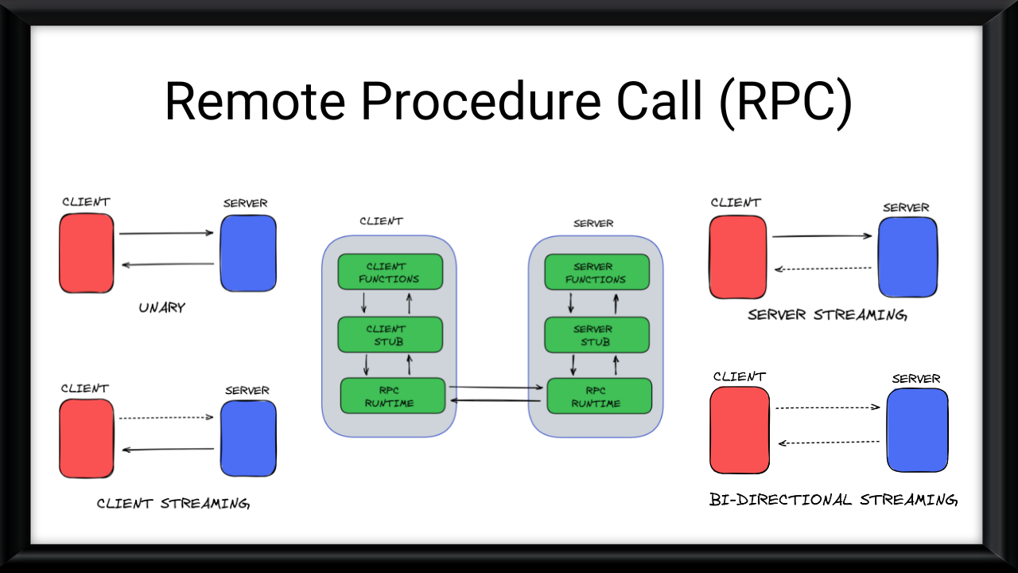

**Simple Object Access Protocol (SOAP)**

* SOAP is a protocol for exchanging structured information in a distributed systems based on XML (extensible markup language) format. SOAP entails a set of syntax rules for request and response. This way, SOAP APIs enables XML communication between software via HTTP. SOAP is a highly secure data transmission protocol used in enterprise, payment systems, CRM, financial serviced, and telecommunication.

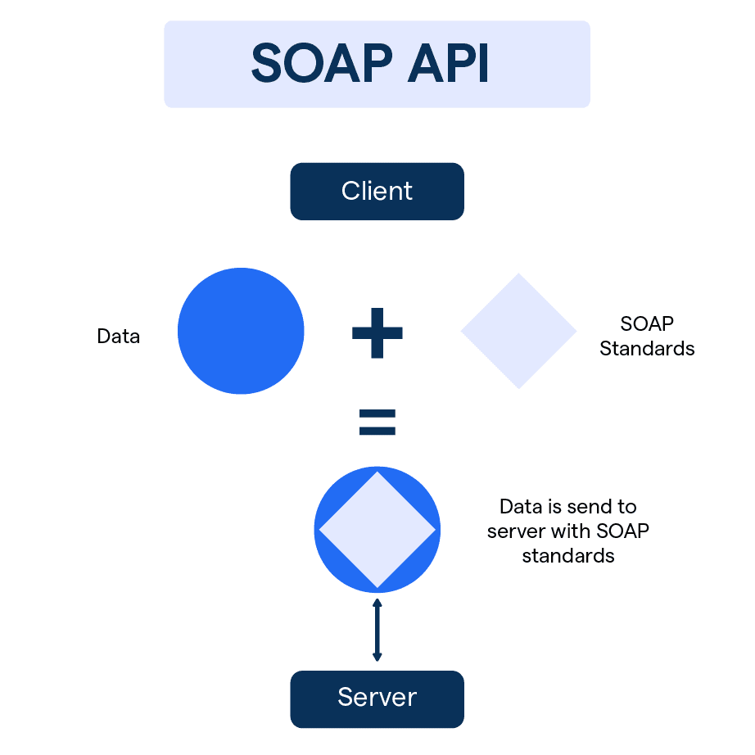

**Representational State Transfer (REST)**

* REST is a software architecture style that is oriented at using HTTP as a transport protocol. Web APIs that comply with the six constraints of REST are called RESTful. World Wide Web is the most popular REST system. Another good example of a RESTful API is Twitter API.

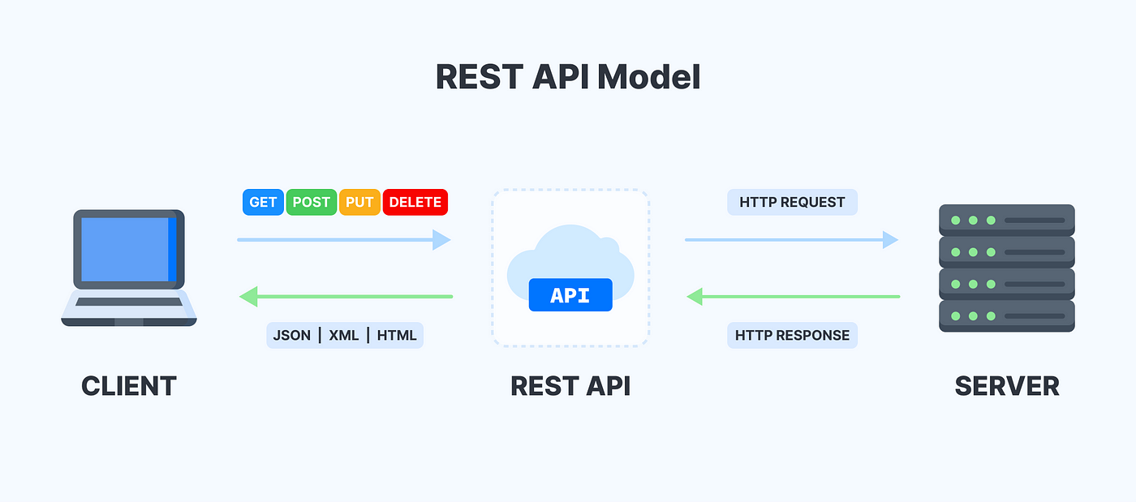

**GraphQL**

* GraphQL is an open-source query language for API developed by Facebook in 2015. It was created as an alternative to REST for developing and using application programming interfaces. GraphQL allows the client to specify exactly what data they need and facilitates the aggregation of data from multiple sources. GraphQL is a good way to speed up development and create more powerful APIs.

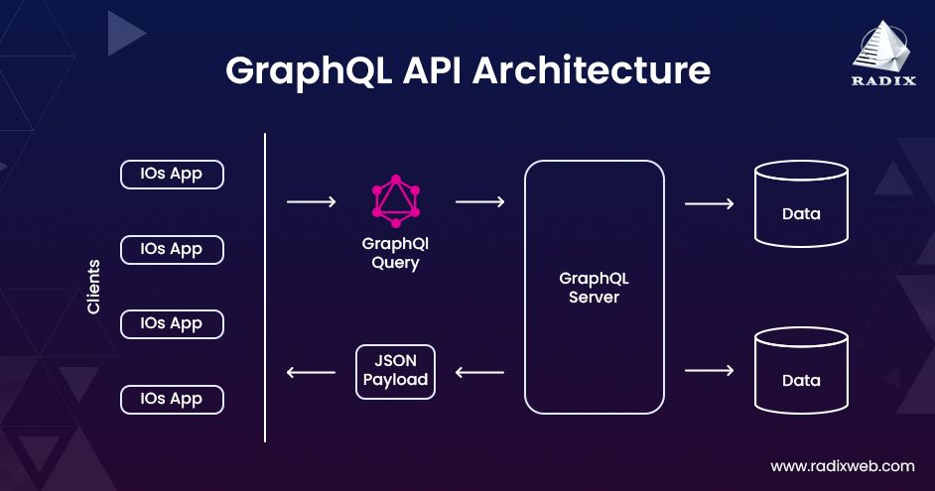

**Comparsion**

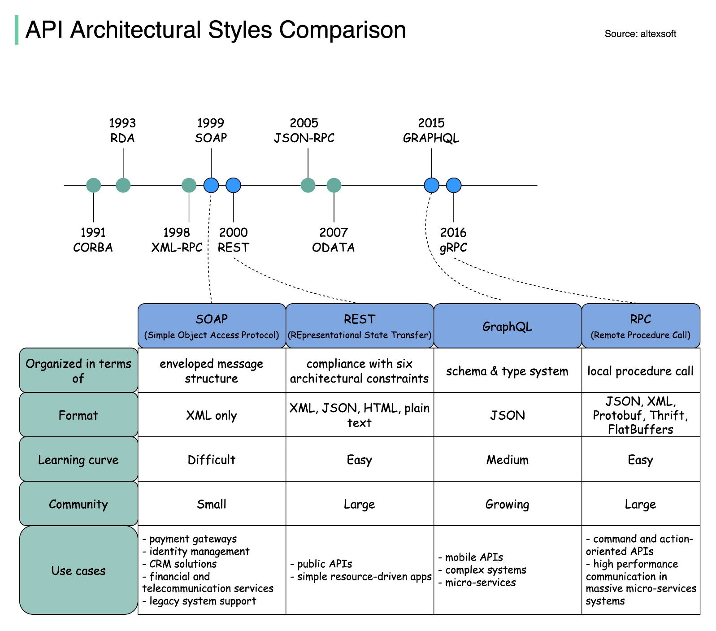

**More Information**

[7 Items No API Documentation Can Live Without | Nordic APIs |](https://nordicapis.com/7-items-no-api-documentation-can-live-without/)